Pioneers of Plate Tectonics

**Harry Hammond Hess (1906 - 1969)**

Harry Hess was a professor of geology at Princeton University (USA), and became interested in the geology of the oceans while serving in the US Navy in World War II. His time as a Navy officer was an opportunity to use **sonar** (also called echo sounding), then a new technology, to map the ocean floor across the North Pacific.

He published ‘**The History of Ocean Basins**' in 1962, in which he outlined a theory that could explain how the continents could actually drift. This theory later became known as ‘**Sea Floor Spreading**'.

Hess discovered that the oceans were shallower in the middle and identified the presence of **Mid Ocean Ridges**, raised above the surrounding generally flat sea floor ([**abyssal plain**](https://www.geolsoc.org.uk/Plate-Tectonics/Glossary/A-C#abyssal)) by as much as 1.5 km. In addition he found that the deepest parts of the oceans were very close to continental margins in the Pacific with Ocean Trenches extending down to depths of over 11 km in the case of the Marianas Trench off the coast of Japan.

Hess envisaged that oceans grew from their centres, with molten material (basalt) oozing up from the Earth’s mantle along the mid ocean ridges. This created new seafloor which then spread away from the ridge in both directions. The ocean ridge was thermally expanded and consequently higher than the ocean floor further away. As spreading continued, the older ocean floor cooled and subsided to the level of the abyssal plain which is approximately 4 km deep.

Hess believed that ocean trenches were the locations where ocean floor was destroyed and recycled. Although his theory made sense, Hess knew, like Wegener, that he still needed convincing geophysical evidence to support it. This was to come just a year after his 1962 publication.

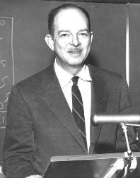

**Left: Drummond Matthews (1931 - 1997)   
Right: Frederick Vine (1939 - present)**

Their work looked at the patterns of magnetic stripes on the ocean floor. If Hess was right, they hypothesised, the symmetrical pattern of stripes was no accident, but indicated that the Earth’s **magnetic field** switches direction over time, from its current (normal) direction to the opposite (reversed) direction. When material from the mantle rises up through mid-ocean ridges and cools, it preserves a record of the polarity of the Earth’s magnetic field. This is because magnetite in the basalts is strongly magnetic, and aligns with the field when it cools.  
  
Vine and Matthews noticed there was a symmetrical pattern of **magnetic stripes** on either side of the mid ocean ridges. In addition when the basalts of the sea floor were dated, they were found to be the same age at similar distances away from the ridge on each side. This suggested that the ocean floor was created at the mid ocean ridges, then was split in half by later activity and pushed sideways.

They published the idea in 1963 in a Nature paper called ‘**Magnetic anomalies over oceanic ridges’**. It became known as the **Vine-Matthews-Morley hypothesis**, recognising the work of Canadian geologist Lawrence Morley who had independently come up with the same idea. It became the first scientific test of **sea floor spreading**, and a crucial development in the theory of Plate Tectonics.

*Image courtesy of the Naked Science Society*

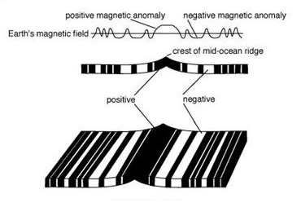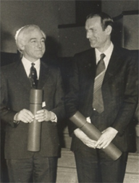

**John Tuzo-Wilson (1908 - 1993)**

The Canadian geophysicist John Tuzo-Wilson was initially sceptical of the theory of Plate Tectonics, but eventually became one of its most famous supporters, proposing two important ideas.

While evidence for **Continental Drift** was mounting, the theory still hadn’t explained why active volcanoes are found many thousands of kilometres from the nearest plate boundary. In 1963, Tuzo-Wilson proposed that plates might move over fixed ‘[**hotspots**](https://www.geolsoc.org.uk/Plate-Tectonics/Glossary/D-L#hotspot)’ in the mantle, forming volcanic island chains like Hawaii.

In 1965, he followed this discovery with the idea of a third type of plate boundary - **transform faults**. Also known as a **conservative plate boundaries**, these faults slip horizontally, connecting oceanic ridges (divergent boundaries) to ocean trenches (convergent boundaries) Transform faults were regarded as the missing piece in the puzzle of plate tectonic theory. They allowed for plates to slide past each other without any oceanic crust being created or destroyed. The most famous example is probably the San Andreas Fault between the North American and Pacific plates.

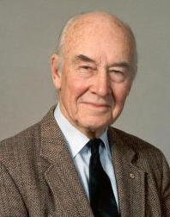

**Dan McKenzie (1942 - present)**

With evidence for Continental Drift now accumulating rapidly, it was still proving difficult to establish what the mechanism for the plate movement was. In 1966, 51 years after Wegener clarified the problem, Dan McKenzie had just submitted his PhD on convection in the Earth’s mantle to Cambridge University when he attended a conference in New York, where he heard Fred Vine speak about **sea floor spreading** and **magnetic anomalies**.

McKenzie applied his knowledge of thermodynamics to the problem of how plates move, and came up with a model which demonstrated a far more dynamic Earth than anyone had previously thought. He suggested there are two layers in the mantle, each of which are in motion, controlling the movement and behaviour of the tectonic plates above. ‘The viscosity of the lower mantle’ was published in 1966.

McKenzie has also modelled the generation of magmas at both mid ocean ridges and mantle plumes/hot spots. He helped develop our understanding of the factors controlling the partial melting of the mantle, and how the original composition of the magma may change with time as it moves upwards, cools and mixes with other magmas at shallower levels. Following on from this work McKenzie has extended his studies to the plate tectonics of other planets, notably Venus and Mars.

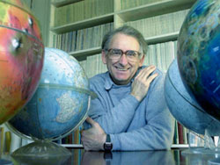

Reference: THE GEOLOGICAL SOCIETY OF LONDON, *Pioneers of Plate Tectonics* [online], date visited 6/04/2020, <https://www.geolsoc.org.uk/Plate-Tectonics/Chap1-Pioneers-of-Plate-Tectonics>